**MEDLINE Search Strategy**

# MEDLINE Search Strategy

*Ovid MEDLINE(R) Epub Ahead of Print, In-Process & Other Non-Indexed Citations, Ovid MEDLINE(R) Daily and Ovid MEDLINE(R)*

1. Retinopathy of Prematurity/

2. exp Ophthalmoscopy/

3. retinopath*.tw.

4. retrolental fibroplasia?.tw.

5. ophthalmoscop*.tw.

6. (scleral adj (depress* or indent*)).tw.

7. 1 or 2 or 3 or 4 or 5 or 6

8. exp Infant, Newborn/

9. ((prematur* or pre-matur* or preterm* or pre-term*) adj2 (infant* or newborn? or baby or babies or neonat* or neo-nat* or child*)).tw.

10. (premie? or preemie?).tw.

11. (low adj2 (birthweight? or birth weight?)).tw.

12. (small adj2 gestation* age).tw.

13. 8 or 9 or 10 or 11 or 12

14. exp Pain/

15. Pain Management/

16. Pain Measurement/

17. exp Analgesia/

18. exp Analgesics/

19. Anesthetics, Local/

20. pain*.tw.

21. analgesia.tw.

22. analgesic?.tw.

23. (local* adj2 anesthetic?).tw.

24. comfort*.tw.

25. discomfort*.tw.

26. stress*.tw.

27. sooth*.tw.

28. (pacify* or pacifie*).tw.

29. 14 or 15 or 16 or 17 or 18 or 19 or 20 or 21 or 22 or 23 or 24 or 25 or 26 or 27 or 28

30. 7 and 13 and 29

|  |  |  |
| --- | --- | --- |
| **Supplementary table 1.** Intervention lumping | | |
| **Intervention** | **Group** | **Rationale/Description** |
| *No anesthetic eye drops* |  |  |
| Non-nutritive sucking | Physical | Mechanism of action through distraction |
| Placebo | Placebo | - |
| Sweet taste alone | Sweet taste alone | Sucrose and glucose combined, similar mechanism |
| Repeated sweet taste |  |  |
| sweet.sing |  | sweet sing |
| *Anesthetic eye drops* | | |
| Alone | Eye drops alone | - |
| No speculum | Eye drops + no speculum | Speculum thought to be major painful component of intervention |
| Sweet taste | Eye drops + sweet | Sucrose + glucose combined, similar mechanism |
| WFDRI | Eye drops + WFDRI | Camera does not require scleral depression and can be done more rapidly |
| Feeding one hour prior | Eye drops + diet one hour | Infants fed one hour before procedure |
| Feeding two hours prior | Eye drops + diet two hours | Infants fed two hours before procedure |
| Non-nutritive sucking | Eye drops + physical | Mechanism of action through distraction |
| Sweet + nitrous oxide | Eye drops + sweet + N2O | Sweet taste combined with additional pharmacological intervention |
| Acetaminophen 30 minutes prior to procedure | Eye drops + acetaminophen 30 minutes | Time of onset of acetaminophen in neonates approximately 60 minutes |
| Acetaminophen 60 minutes prior to procedure | Eye drops + acetaminophen 60 minutes |
| Sensorial saturation | Eye drops + sweet multisensory | Combines sweet taste, non-nutritive sucking, swaddling, touch, voice, and familiar odour |
| NIDCAP | Eye drops + sweet multisensory | Combines sweet taste, non-nutritive sucking, swaddling, touch, and voice |
| Cup-fed expressed breast milk | Eye drops + ebm multisensory | Cup feeding provides olfactory and gustatory stimulation |
| Expressed breast milk + non-nutritive sucking | Eye drops + ebm multisensory | Combines gustatory and physical stimulation |

|  |  |  |  |  |  |  |  |
| --- | --- | --- | --- | --- | --- | --- | --- |
| **Supplementary table 2.** Characteristics of studies | | | | | | | |
| Author and year | Design | Method | Speculum | Scleral depression | PMA (mean) | BW (mean) | Treatments |
| Boyle 2006 | Parallel | BIO | yes | yes | 34.9 | 1132.8 | drops vs drops + sweet vs NNS + drops vs sweet + nns + drops |
| Cogen 2011 | Parallel | BIO | yes | yes | 34 | 924 | no treatment vs drops |
| Costa 2013 | Parallel | BIO | yes | yes | 35.2 | 1260.9 | drops vs drops + sweet |
| Dhaliwal 2010 | Crossover | WFDRI | yes | no | 34.1 | 1208 | drops vs WFDRI + drops |
| Dilli 2014 | Parallel | BIO | yes | unclear | 35.4 | 1304 | drops + nns vs sweet + nns + drops |
| Gal 2005 | Crossover | BIO | yes | yes | 33.3 | NA | drops vs drops + sweet |
| Grabska 2005 | Parallel | BIO | yes | yes | 35.3 | 1880 | drops + nns vs sweet + nns + drops |
| Kabatas 2016 | Parallel | BIO | yes | unclear | 32.4 | 1130.3 | drops vs paracetamol + drops |
| Kleberg 2008 | Crossover | BIO or WFDRI | yes | yes in London | NA | NA | drops vs NIDCAP |
| Mandel 2012 | Parallel | BIO | yes | yes | 35.2 | 1025.4 | drops + sweet vs NO + sweet + drops |
| Marsh 2005 | Crossover | BIO | yes | yes | 33 | NA | no + treatment vs drops |
| Mehta 2010 | Crossover | BIO | yes | yes | NA | NA | nns vs NNS + drops |
| Mitchell 2004 | Parallel | BIO | yes | yes | 35.2 | 976 | drops + nns vs sweet + nns + drops |
| Nesargi 2015 | Parallel | BIO | yes | yes | 34.3 | 1167 | drops vs sweet |
| Olsson 2011 | Parallel | BIO | no | unclear | NA | 1126.5 | drops vs drops + sweet |
| O'sullivan 2010 | Parallel | BIO | yes | yes | 33.1 | 1140 | drops + nns vs sweet + nns + drops |
| Rosali 2015 | Parallel | BIO | yes | yes | 34.6 | 1356 | drops vs ebm + drops |
| Rush 2005 | Parallel | BIO | yes | unclear | NA | 1185.3 | drops vs sweet + nns + drops |
| Saunders 1993 | Parallel | BIO | yes | yes | 36 | 1093 | no treatment vs drops |
| Strube 2010 | Parallel | BIO | yes | yes | 35.8 | 1091.7 | 1hr + feed vs 2hr + feed |
| Manjunatha 2009 | Parallel | BIO | yes | yes | NA | NA | drops vs morphine + drops vs paracetamol + drops |
| Seifi 2013 | Parallel | BIO | yes | yes | NA | 987.1 | drops vs drops + sweet vs paracetamol + drops |
| Zeraati 2016 | Parallel | unclear | unclear | unclear | 35.5 | 1370.8 | drops vs sensorial + saturation |
| SenerTaplak 2017 | Parallel | BIO | yes | yes | NA | NA | drops + nns vs nns + ebm + drops vs nns + sweet + drops |
| Benzer 2015 | Parallel | unclear | unclear | unclear | NA | NA | plac vs sweet + rep vs sweet + single |
| Ilarslan 2012 | Parallel | unclear | yes | unclear | NA | NA | drops + nns vs nns + drops + sweet |
| Mehta 2005 | Crossover | bio and wfdri | yes | no | NA | NA | drops + bio + spec vs drops + bio + nospec vs drops + wfdri |
| Ucar 2014 | Parallel | unclear | unclear | unclear | 34.2 | 1280 | drops + nns vs drops + sweet vs sweet + nns + drops |
| Xin 2016 | Parallel | unclear | unclear | unclear | NA | NA | drops vs drops + sweet |

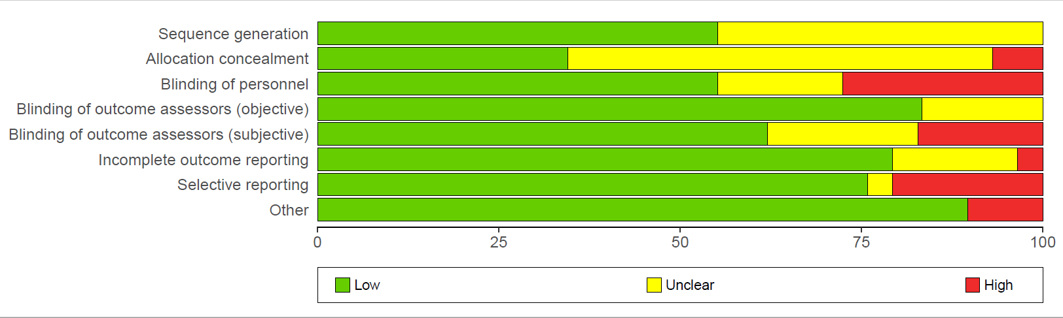

Supplementary figure . Risk of Bias of included studies